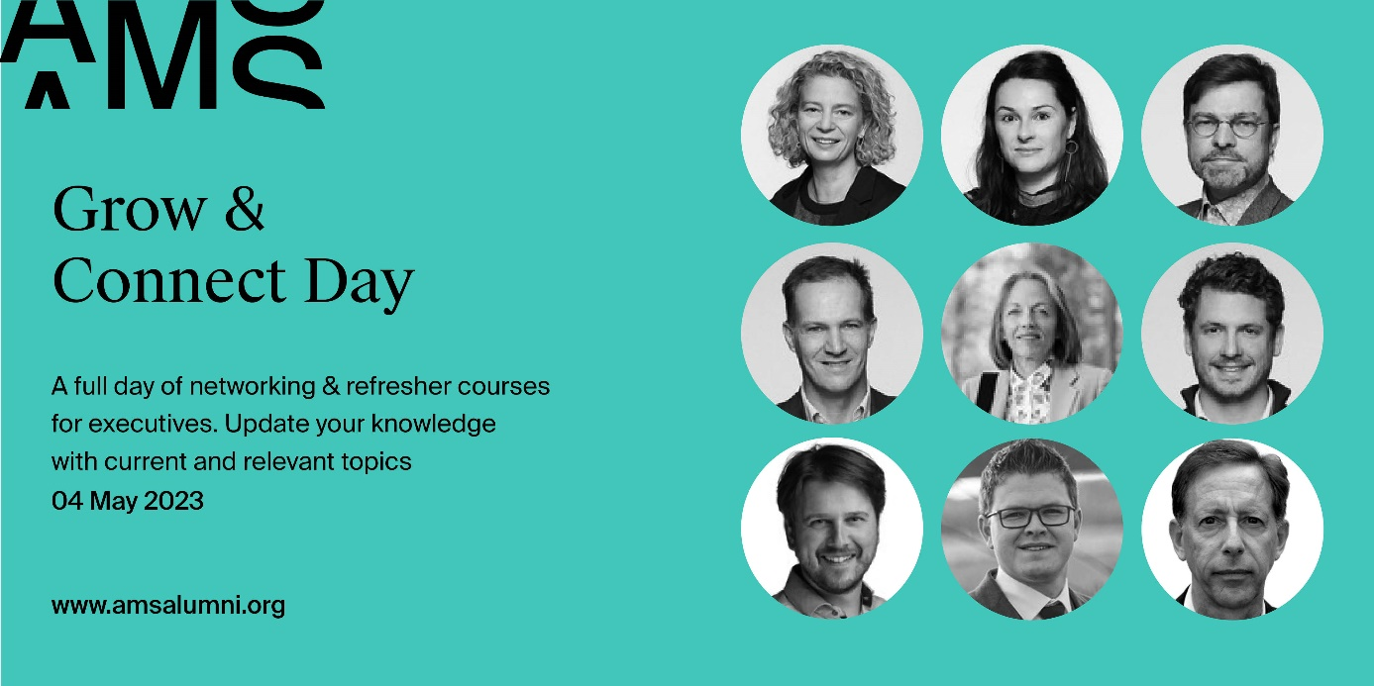
Registration form for companies with 5 participants or more:
price pp (ex. Btw) 350 EUR
please fill in the form below and return it to emmanuelle.duval@ams.ac.be
Each participant will receive an email confirming their registration.

Company details
Company Name:
VAT Number:
Address:
email of the contact person for invoicing:
Participant 1:
First name:
Last name
Email
Job title:
company name:
What are 2 words that describe your passions?
if you have any dietary restrictions, please indicate them here:
morning session selection: (pick 1)
- Managing the pathways of digital transformation, by Steven De Haes
- Thriving - business strategies to regenerate nature, society and the economy, by Wayne Visser
- Sustainable careers - happy, healthy & productive, by Ans De Vos and Sofie Jacobs
- How to get the price right, by Pol Vanaerde
afternoon sessions (pick 1)
- Building and leading innovative teams, by Robin De Cock
- A journey of a sail trip through a global "perfect storm" in supply chains by Roel Gevaers including live contributions by top experts Koen De Leus (Chief Economist BNP Paribas Fortis) & Prof. Wouter Dewulf (Air freight expert)
- The change manager does not exist – team work makes the dream work, by Daan Sorgeloos (sold out)
- The use of platform businesses in the spurt to a circular economy, by Carla I. Koen

Participant 2:
First name:
Last name
Email
Job title:
company name:
What are 2 words that describe your passions?
if you have any dietary restrictions, please indicate them here:
morning session selection: (pick 1)
- Managing the pathways of digital transformation, by Steven De Haes
- Thriving - business strategies to regenerate nature, society and the economy, by Wayne Visser
- Sustainable careers - happy, healthy & productive, by Ans De Vos and Sofie Jacobs
- How to get the price right, by Pol Vanaerde
afternoon sessions (pick 1)
- Building and leading innovative teams, by Robin De Cock
- A journey of a sail trip through a global "perfect storm" in supply chains by Roel Gevaers including live contributions by top experts Koen De Leus (Chief Economist BNP Paribas Fortis) & Prof. Wouter Dewulf (Air freight expert)
- The change manager does not exist – team work makes the dream work, by Daan Sorgeloos (sold out)
- The use of platform businesses in the spurt to a circular economy, by Carla I. Koen

Participant 3:
First name:
Last name
Email
Job title:
company name:
What are 2 words that describe your passions?
if you have any dietary resitrictions, please indicate them here:
morning session selection: (pick 1)
- Managing the pathways of digital transformation, by Steven De Haes
- Thriving - business strategies to regenerate nature, society and the economy, by Wayne Visser
- Sustainable careers - happy, healthy & productive, by Ans De Vos and Sofie Jacobs
- How to get the price right, by Pol Vanaerde
afternoon sessions (pick 1)
- Building and leading innovative teams, by Robin De Cock
- A journey of a sail trip through a global "perfect storm" in supply chains by Roel Gevaers including live contributions by top experts Koen De Leus (Chief Economist BNP Paribas Fortis) & Prof. Wouter Dewulf (Air freight expert)
- The change manager does not exist – team work makes the dream work, by Daan Sorgeloos (sold out)
- The use of platform businesses in the spurt to a circular economy, by Carla I. Koen

Participant 4:
First name:
Last name
Email
Job title:
company name:
What are 2 words that describe your passions?
if you have any dietary restrictions, please indicate them here:
morning session selection: (pick 1)
- Managing the pathways of digital transformation, by Steven De Haes
- Thriving - business strategies to regenerate nature, society and the economy, by Wayne Visser
- Sustainable careers - happy, healthy & productive, by Ans De Vos and Sofie Jacobs
- How to get the price right, by Pol Vanaerde
afternoon sessions (pick 1)
- Building and leading innovative teams, by Robin De Cock
- A journey of a sail trip through a global "perfect storm" in supply chains by Roel Gevaers including live contributions by top experts Koen De Leus (Chief Economist BNP Paribas Fortis) & Prof. Wouter Dewulf (Air freight expert)
- The change manager does not exist – team work makes the dream work, by Daan Sorgeloos (sold out)
- The use of platform businesses in the spurt to a circular economy, by Carla I. Koen
Participant 5:
First name:
Last name
Email
Job title:
company name:
What are 2 words that describe your passions?
if you have any dietary restrictions, please indicate them here:
morning session selection: (pick 1)
- Managing the pathways of digital transformation, by Steven De Haes
- Thriving - business strategies to regenerate nature, society and the economy, by Wayne Visser
- Sustainable careers - happy, healthy & productive, by Ans De Vos and Sofie Jacobs
- How to get the price right, by Pol Vanaerde
afternoon sessions (pick 1)
- Building and leading innovative teams, by Robin De Cock
- A journey of a sail trip through a global "perfect storm" in supply chains by Roel Gevaers including live contributions by top experts Koen De Leus (Chief Economist BNP Paribas Fortis) & Prof. Wouter Dewulf (Air freight expert)
- The change manager does not exist – team work makes the dream work, by Daan Sorgeloos (sold out)
- The use of platform businesses in the spurt to a circular economy, by Carla I. Koen

Participant 6
First name:
Last name
Email
Job title:
company name:
What are 2 words that describe your passions?
if you have any dietary restrictions, please indicate them here:
morning session selection: (pick 1)
- Managing the pathways of digital transformation, by Steven De Haes
- Thriving - business strategies to regenerate nature, society and the economy, by Wayne Visser
- Sustainable careers - happy, healthy & productive, by Ans De Vos and Sofie Jacobs
- How to get the price right, by Pol Vanaerde
afternoon sessions (pick 1)
- Building and leading innovative teams, by Robin De Cock
- A journey of a sail trip through a global "perfect storm" in supply chains by Roel Gevaers including live contributions by top experts Koen De Leus (Chief Economist BNP Paribas Fortis) & Prof. Wouter Dewulf (Air freight expert)
- The change manager does not exist – team work makes the dream work, by Daan Sorgeloos (sold out)
- The use of platform businesses in the spurt to a circular economy, by Carla I. Koen
Participant 7:
First name:
Last name
Email
Job title:
company name:
What are 2 words that describe your passions?
if you have any dietary restrictions, please indicate them here:
morning session selection: (pick 1)
- Managing the pathways of digital transformation, by Steven De Haes
- Thriving - business strategies to regenerate nature, society and the economy, by Wayne Visser
- Sustainable careers - happy, healthy & productive, by Ans De Vos and Sofie Jacobs
- How to get the price right, by Pol Vanaerde
afternoon sessions (pick 1)
- Building and leading innovative teams, by Robin De Cock
- A journey of a sail trip through a global "perfect storm" in supply chains by Roel Gevaers including live contributions by top experts Koen De Leus (Chief Economist BNP Paribas Fortis) & Prof. Wouter Dewulf (Air freight expert)
- The change manager does not exist – team work makes the dream work, by Daan Sorgeloos (sold out)
- The use of platform businesses in the spurt to a circular economy, by Carla I. Koen

